Process Definition Document (PDD)

*Process Name: <* CalculateYearlyProfits *>*

Table of Contents

**Introduction** **1**

Purpose of the Document 1

Objectives 1

Process Key Contact 1

Minimum Prerequisites for Automation 1

**As-Is Process Description** **2**

Process Overview 2

Applications used in the Process 3

As-Is Process Map 3

**To-Be Process Description** **3**

Detailed Process Map 3

Robot Type 4

Business Exceptions Handling 4

Known Exceptions 4

Unknown Exceptions 4

System Exceptions Handling 4

**Other Observations** **5**

**Additional sources of process documentation** **5**



# Introduction

## Purpose of the Document

The Process Definition Document outlines the business process chosen for automation using UiPath Robotic Process Automation (RPA) technology.

The document describes the sequence of steps performed as part of the business process, the conditions and rules of the process prior to automation and how they are envisioned to work after automating it, partly or entirely. This specifications document serves as a base for developers, providing them with the details required for applying robotic process automation to the selected business process.

## Objectives

The business objectives and benefits expected by the Business Process Owner after automation of the selected business process are:

* Scrap all the financial information from pdfs that are mailed to the accountant department.
* Process this information and send the profits report to the manager email.
* The process should run at the beginning of the year.

## Process Key Contact

The specifications document includes concise and complete requirements of the business process and it is built based on the inputs provided by the process Subject Matter Expert (SME)/ Process Owner.

The Process Owner is expected to review it and provide signoff for accuracy and completion of the steps, context, impact and a set of process exceptions. The details are to be included in the table below.

|  |  |  |  |
| --- | --- | --- | --- |
| Role | Name | Contact Details  (email & phone number) | Notes |
| Process Owner | Attia sayed | attiasayed1997@gmail.com |  |
| Business Analyst | Attia sayed | attiasayed1998@outlook.com |  |

## Minimum Prerequisites for Automation

|  |  |
| --- | --- |
| Met (Y/N) | Prerequisites |
| Y | A filled in and completed Process Definition Document |
| Y | Closure of any open process questions |
| Y | Environment set up |
| Y | Test Data to support development and testing |
|  | User access and creation of user accounts (licences, permissions, restriction to create accounts for robots) |

# As-Is Process Description

## Process Overview

General information about the process selected for RPA prior to automation.

|  |  |  |
| --- | --- | --- |
| # | Item | Description |
| 1 | Process Full Name | CalculateYearlyProfits |
| 2 | Process Area | Personal |
| 3 | Department | Finance |
| 4 | Process Short Description  (operation, activity, outcome) | Calculate year profits of some business project. |
| 5 | Role(s) required for performing the process | Any |
| 6 | Process schedule and frequency | Every Year |
| 7 | # of items processed /reference period | 12 |
| 8 | Process execution time | N/A |
| 9 | Peak period(s) | N/A |
| 10 | Transaction Volume During Peak period | N/A |
| 11 | Total # of FTEs supporting this activity | N/A |
| 12 | Expected increase of volume in the next reference period | N/A |
| 13 | Level of exception rate |  |
| 14 | Input data | Fainance accout and pdf attachments sent by manager mail |
| 15 | Output data |  |

*Add more rows to the table to include relevant data for the automation process. No fields should be left empty. Use “n/a” for the items that don't apply to the selected business process.

## Applications used in the Process

The table includes a comprehensive list of all the applications that are used as part of the process to be automated to perform the given steps in the flow.

|  |  |  |  |  |  |
| --- | --- | --- | --- | --- | --- |
| # | Application Name & Version | System Language | Thin/Thick Client | Environment/ Access Method | Comments |
| 1 | AdobeAcrobatProDC2020.012.20048 | English | Thick | PC |  |
| 2 | Microsoft Excel  2014 | English | Thick | PC |  |
| 3 | Microsoft Outlook  2014 | English | Thick | PC | The Email should be signed in. |

*Add more rows to the table to include the complete list of applications.

## As-Is Process Map

**High Level As-Is Process Map:** This chapter depicts the As-Is business process at a High Level to enable developers to have a high-level understanding of the current process.

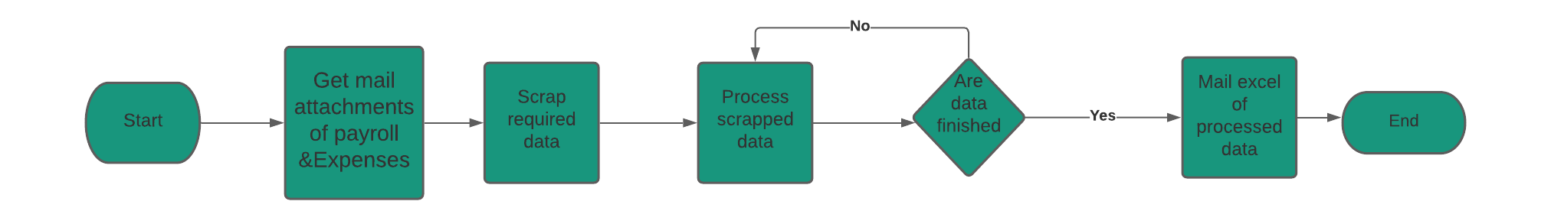

**Detailed Process Map:** This chapter depicts the As-Is business process at a detailed view to enable process owners to document their process

|  |  |  |  |
| --- | --- | --- | --- |
| # | Step Action/Description | Screenshot | Remarks |
| 1 | Retrieve Finance Mail messages | N/A |  |
| 2 | Filter and save pdf attachments of payrolls & Expenses | N/A |  |
| 3 | Open every month pdf to scrap the data to be processed |  | Two Pdfs in every month each for payroll and the other for expenses |
| 4 | Calculate every month profit | N/A |  |
| 5 | Make the excel invoice of the total year profit |  |  |
| 6 | Mail the excel file to the manager | N/A |  |

# To-Be Process Description

## Detailed Process Map

**High Level To-Be Process Map:** This chapter depicts the To-Be automation process at a High Level to enable developers/COE to have a high-level understanding of the to be developed process.

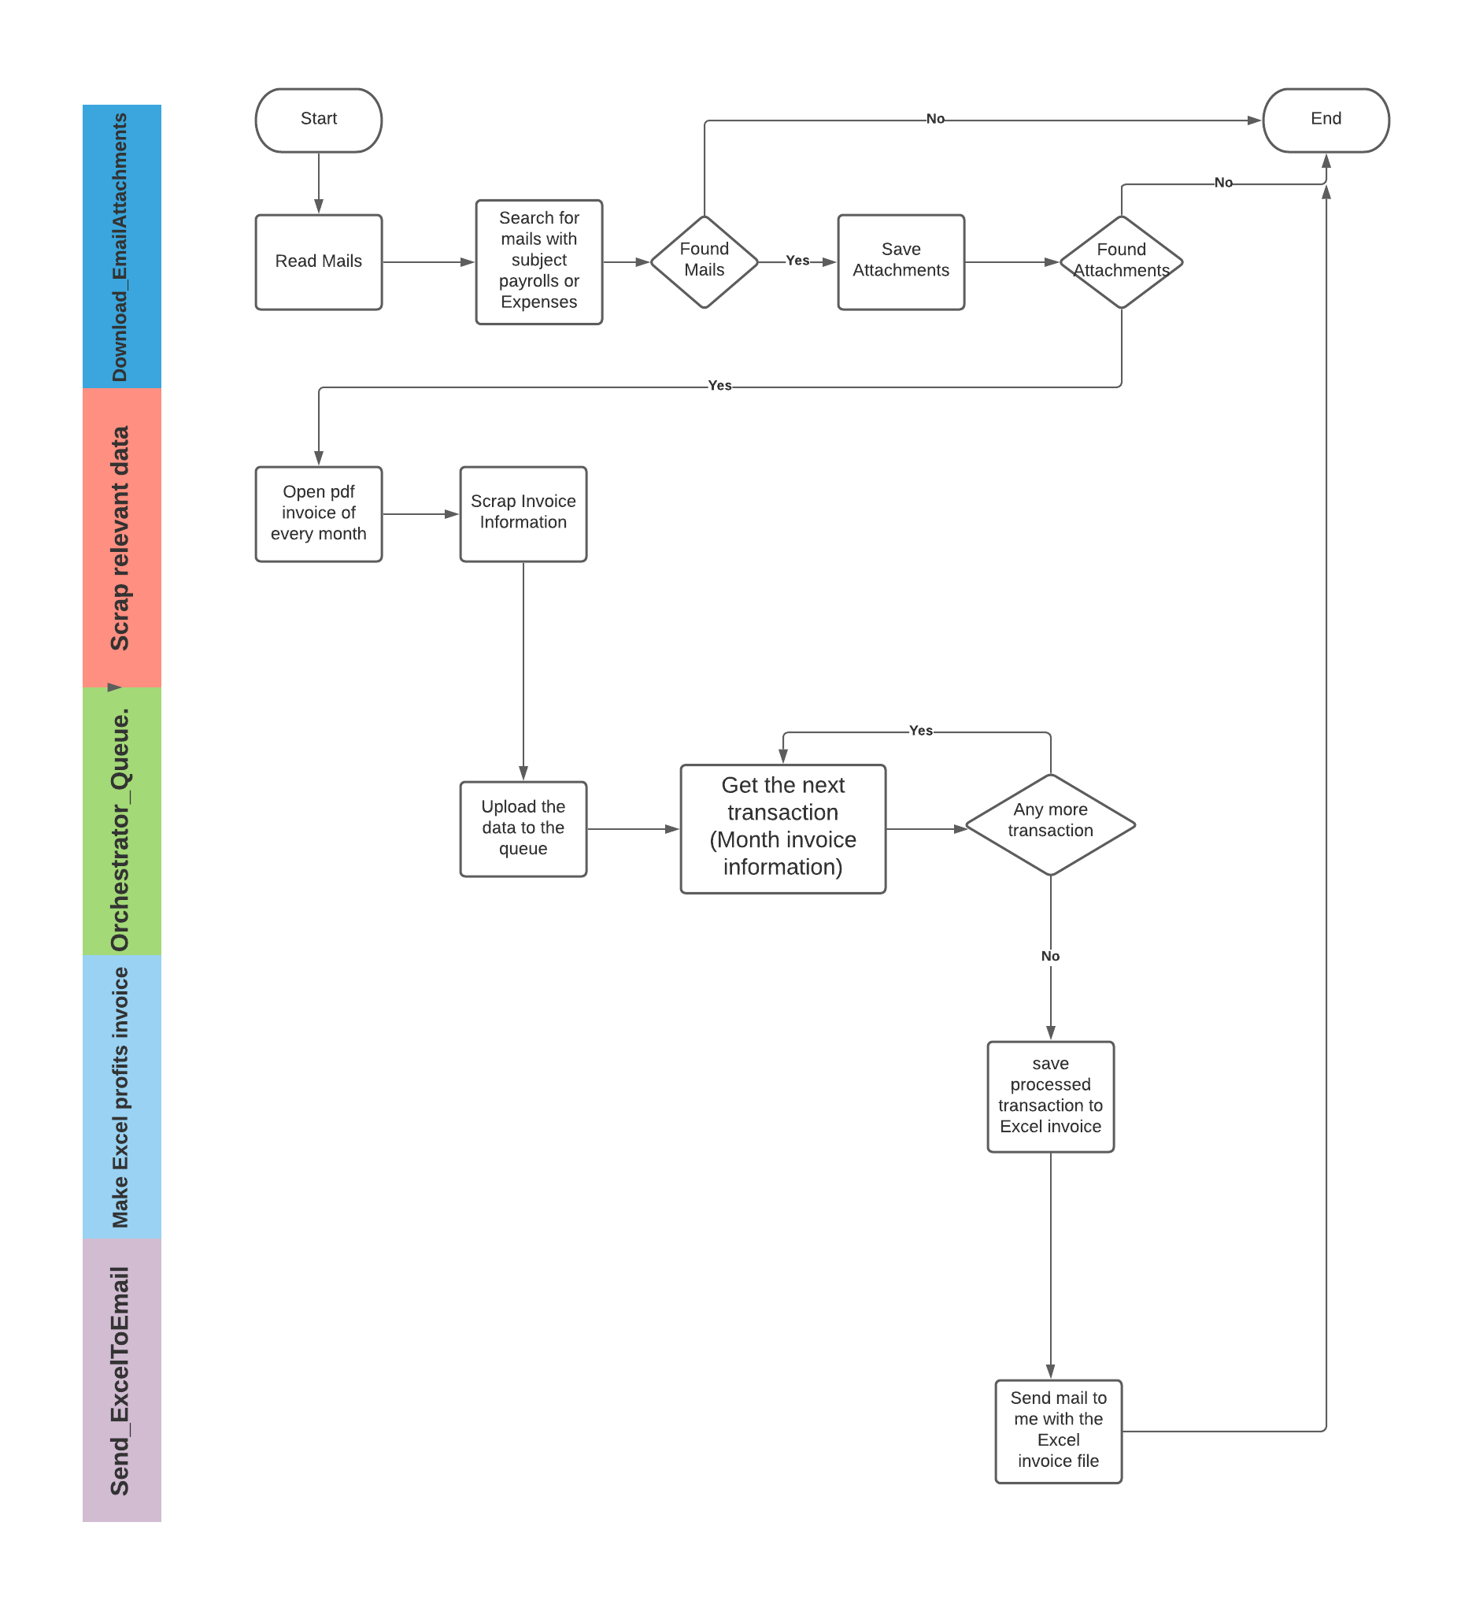

**Detailed Process Map:** This chapter depicts the To-Be automation process at a detailed view to enable developers/COE to see the workflows involved in the RPA solution

|  |  |  |  |  |  |
| --- | --- | --- | --- | --- | --- |
| **Workflow Name** | **Description** | **Pre-conditions** | **Post-actions** | **Arguments** | **Notes** |
| Outlook_RetrieveMails | -Get Asset - Fainancial Account that has the mails to be retrieved.  -Retrieve all mails  -Filter mails with subject payroll save its attachments in payroll folder  -Filter mails with subject expensessave its attachments in expenses folder  -check if all attachments are downloaded and sorted successfully | outlook package is installed.  Mails are ready to be retrieved | Attacments are downloaded sucessfully.  Attacments are filterded sucessfully. | -in_ExpenssesPath  -in_PayrollPath |  |
| Acrobat_GetInf_PopulateQ | -check if the PDFS are downloaded and filtered successfully.  -loop through every month of each PDF in payroll pdfs to scrap the balance and payroll total payment and date also and each PDF in Expenses pdfs to scrap Total expenses of the same month.  -Populate Q_items of scrapped data. | -PDFS are downloaded and filtered successfully | -Information are scrapped successfully and uploaded to the Queue | -in_OrchestratorQName  in_ExpenssesPath  -in_PayrollPath |  |
| Acrobat_Orchestrator_Queue | This workflow helps in uploading the Scrapped Information to the Orchestrator Queue | - Successful extraction of ( The balance ,payroll total payment ,date and expenses total also)  - The item is not uploaded to the Queue before | N/A | in_InvoiceDate  in_OrchestratorQName  in_InvoiceBalance  in_InvoicePayroll  in_ExpensesTotal |  |
| ProcessingTransactions | Gets all queue transactions and process them all. | N/A | All Transactions are processed successfully. | in_OrchestratorQName  io_ProfitsCalculationDT |  |
| ProcessCurrentTransaction | Processes the provided transaction item. | The provided transaction item is not nothing. | Transaction item is processed successfully. | in_TransactionItem  io_ProfitsCalculationDT |  |
| Email_YearlyProfit | -Create the Excel yearly profit invoice  -Send Excel invoice file to the manager account. | - The provided data table is not empty.  - All scraped Inf are processed successfully with no errors. | -Year profit excel incoice Emailed to the manager successfully. | in_ProfitsCalculationDT  in_ExcelDirectory |  |
| WriteDataToExcel | -Make Excel invoice of the yearly profit | The provided data table is not empty. | The data is written successfully. | in_Data  in_ExcelDirectory |  |

## Robot Type

|  |  |  |  |  |
| --- | --- | --- | --- | --- |
| # | Attended | Unattended | Trigger | Comments |
| 1 |  | ✓ |  |  |

## Business Exceptions Handling

The Business Process Owner and Business Analysts are expected to document below all the business exceptions identified in the automation process. These can be classified as:

### Known Exceptions

The table below reflects all the business process exceptions encountered during the process evaluation and documentation. These are known exceptions that occurred before. For each of these exceptions, define a corresponding expected action that the robot should complete if it encounters the exception.

|  |  |  |  |  |
| --- | --- | --- | --- | --- |
| BE # | Exception Name | Step | Parameters | Action to be Taken |
| 1 | No payroll or expenses mails. | 1 | N/A | Sends an email to the business exception mail address informing him with the exception. |
| 2 | Payroll mails or expenses mails not complete | 2 | N/A | Sends an email to the business exception mail address informing him with the exception. |

### Unknown Exceptions

For all other unanticipated or unknown business (process) exceptions, the robot should:

## System Exceptions Handling

A comprehensive list of all errors, warnings or notifications should be consolidated here with the description and action to be taken, for each, by the robot.

Errors identified in the automation process can be classified as:

|  |  |  |  |  |
| --- | --- | --- | --- | --- |
| SE # | Exception Name | Step | Parameters | Action to be Taken |
| 1 | Information are not successfully uploaded to the Queue" | 4 | N/A | Retry 3 times and end process |
| 2 | the bot couldn't process all the scraped Month invpice information | 5 | N/A | Retry 3 times and end process |

For all the other unanticipated or unknown system exceptions, send an email to **<placeholder>** and attach a screenshot of the error message.

* Retry 3 times and if the exception stays, take a screenshot to the whole screen and then end the Process.

# Other Observations

Include below any other relevant observations you consider needed to be documented here.

# Additional sources of process documentation

* A recorded video for the process running end to end – in the current directory as the PDD.
* A whiteboard, which is an excel file that contains all the workflows names and information.
* A document that contains the main aspects of the project - in the current directory as the PDD.
* A development specifications document - in the current directory as the PDD.